The Home Children
(p. 16-19)
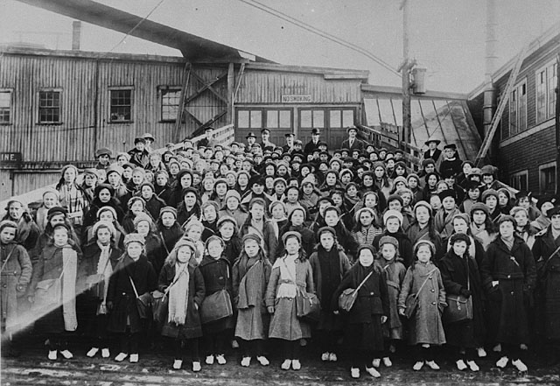

Questions to help you analyze the Home Children feature

- Who had the authority and power in this situation? Was it an individual, an organization, or a national government? (It might Have been more then one of these)
____________________________________________________________________________________________________________________________________________________________________________________________________________________________________________________________________________________________________________________________________________________________________________________________________________________________________________________________________________
- How did they use their power? Describe the choices they made and the actions they took.
____________________________________________________________________________________________________________________________________________________________________________________________________________________________________________________________________________________________________________________________________________________________________________________________________________________________________________________________________________

- Was anyone disempowered by these actions? If so, who and how?
____________________________________________________________________________________________________________________________________________________________________________________________________________________________________________________________________________________________________________________________________________________________________________________________________________________________________________________________________________

- If you had been one of the people who had authority and power in that situation, would you have done something differently? Why or why not? If you would have made different decisions, explain what you have done.
____________________________________________________________________________________________________________________________________________________________________________________________________________________________________________________________________________________________________________________________________________________________________________________________________________________________________________________________________________
- Using your own paper, create (write or draw) a personal response to the story of the Home Children. A personal response is your chance to show your thoughts and feelings on an issue.

