1. Using the map below, create a copy of the map from page 39 of your text book.

Climate Regions

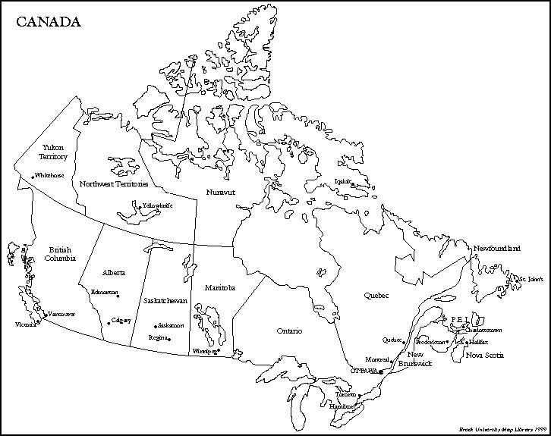

1. Using pages 38 and 39, write a description for each of the 4 types of climate regions in Canada.

|  |
| --- |
|  |
|  |
|  |
|  |
|  |
|  |
|  |
|  |
|  |
|  |
|  |
|  |
|  |
|  |
|  |
|  |
|  |
|  |
|  |
|  |
|  |
|  |
|  |
|  |
|  |

1. What are microclimates and what may cause them?

|  |
| --- |
|  |
|  |
|  |
|  |
|  |
|  |
|  |
|  |
|  |

1. Using the Skills toolbox on page 40, complete a climograph using the following data.

**Location X (Data Collected in 2002)**

|  |  |  |  |  |  |  |  |  |  |  |  |  |
| --- | --- | --- | --- | --- | --- | --- | --- | --- | --- | --- | --- | --- |
| MONTH | J | F | M | A | M | J | J | A | S | O | N | D |
| Temperature (C) | -12.9 | -7.6 | -3.1 | -1 | 8 | 16.3 | 20 | 16.2 | 11.9 | -0.7 | -4.2 | -7.8 |
| Precipitation (cm) | 1.5 | 1.3 | 1.7 | 2.04 | 5.1 | 7.5 | 5.9 | 4.3 | 3.3 | 2.2 | 1.3 | 1.6 |

_________________________

|  |  |  |  |  |  |  |  |  |  |  |  |  |  |  |  |  |  |
| --- | --- | --- | --- | --- | --- | --- | --- | --- | --- | --- | --- | --- | --- | --- | --- | --- | --- |
|  |  |  |  |  |  |  |  |  |  |  |  |  |  |  |  |  |  |
|  |  |  |  |  |  |  |  |  |  |  |  |  |  |  |  |  |  |
|  |  |  |  |  |  |  |  |  |  |  |  |  |  |  |  |  |  |
|  |  |  |  |  |  |  |  |  |  |  |  |  |  |  |  |  |  |
|  |  |  |  |  |  |  |  |  |  |  |  |  |  |  |  |  |  |
|  |  |  |  |  |  |  |  |  |  |  |  |  |  |  |  |  |  |
|  |  |  |  |  |  |  |  |  |  |  |  |  |  |  |  |  |  |
|  |  |  |  |  |  |  |  |  |  |  |  |  |  |  |  |  |  |
|  |  |  |  |  |  |  |  |  |  |  |  |  |  |  |  |  |  |
|  |  |  |  |  |  |  |  |  |  |  |  |  |  |  |  |  |  |
|  |  |  |  |  |  |  |  |  |  |  |  |  |  |  |  |  |  |
|  |  |  |  |  |  |  |  |  |  |  |  |  |  |  |  |  |  |